Robert Kristian Alm
Movant 19/03/2017

6b (VLANs and Trunks for Beginners - Part 2)

Link of the video: https://www.youtube.com/watch?v=-H20S65OB3E

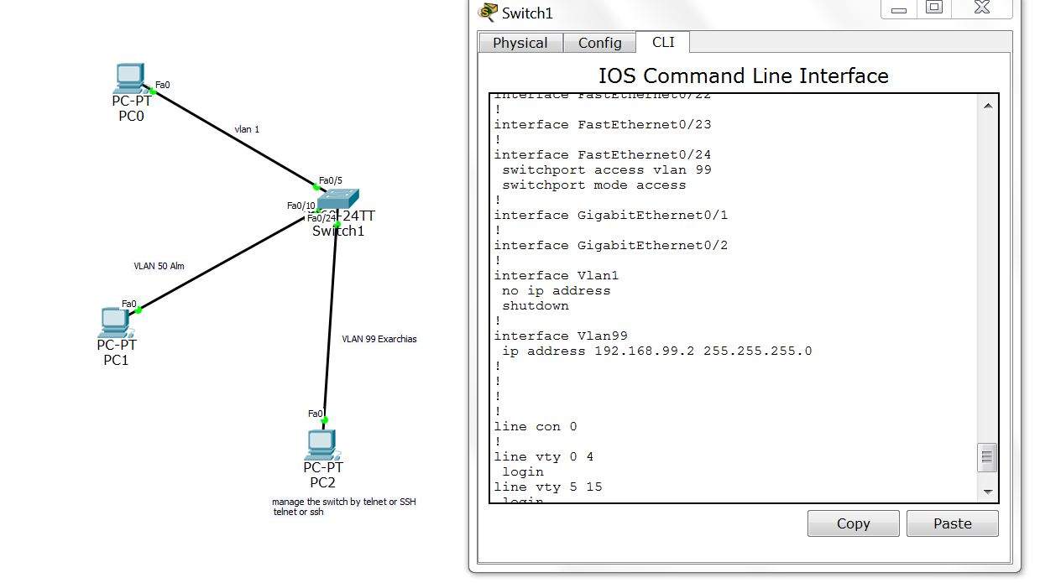

In this part of the assignment we continue from the part that we left on 6a and we add a new generic computer with ip 192.168.99.100/24 that is connected to the switch through the port fa0/24 witch is the port of VLAN 99.
On the second part of the video we inserted an IP, (192.168.99.2), to the vlan 99 in order to be able to access and manage the switch through the manage vlan.
Here I need to explain few things

1. I regretted my decision to name my VLANs alm and exarchias. I did that because of reason of personalization and because I wasn't aware of the point of the the part 2of the series.
2. The point of the part 2 of the assignment is mostly to understood that vlan can have some roles, like the vlan 99 for example witch is designed for management of the switch.
3. For reason of simplicity from now on I will skip the details of conf T and how we move to the in and out of a entity shell, (interface port vlan etc). I believe it is clear that I know exactly how to go in and out to every shell so it will be useful to avoid the many details.
4. I started to use notes on my cisco projects but I ensure you that I am following a motive that every port and every ip have a logical relation between them and of course be aware that my configuration follows up the configuration of the video tutorials.

The main point of the lecture was the vlan 99, (aka exarchias), which is designed for management. This vlan has ip in order to be able the host of vlan 99 to access and manage the switch. On this point is good to point out that it bad practice to insert an IP on vlan1 because is the default lan so it will be the first place that a hacker will search for a port to access the switch.
We gave the ip 192.168.99.2 to the vlan 99, and we tried successfully to ping the interface through the third pc, (PC2 192.168.99.100) so we know that everything works as it should.

